Web Based Graphical Password Authentication System

In this project we are authenticating users via images and this images will be uploaded at signup time and then ask user to click on image 4 times to select 4 different spots and user has to remember those points.

It’s difficult for user’s to select correct pixel X and Y location from mouse click so we provide region based authentication for example

If user select X = 120 and Y = 240 from mouse click then while authentication I deducted 10 pixels from X value and added 10 more pixels to X values which means

If user select X value between 110 to 130 and Y value between 230 and 250 then user get authenticated as actual or original X value 120 and Y value 240 falls between 110 to 130 and 230 to 250

To run project install python 3.7 and MYSQL and then copy content from DB.txt file and paste in MYSQL to create database

To implement this project we have designed following modules

1. Admin Login: using this module admin can login to application using username and password as admin and then after login can view all registered user details
2. New User Signup: using this module user can signup with the application and has to upload image in place of password and then select 4 spots and all this details will saved in database
3. User Login: using this module user can login to application by entering USERNAME and then image will be displayed and user has to select correct spots to get authenticated
4. Reset Password: after login user can update password image and can enter new spots to reset password

SCREEN SHOTS

To run project double click on ‘run.bat’ file to start DJANGO server like below screen

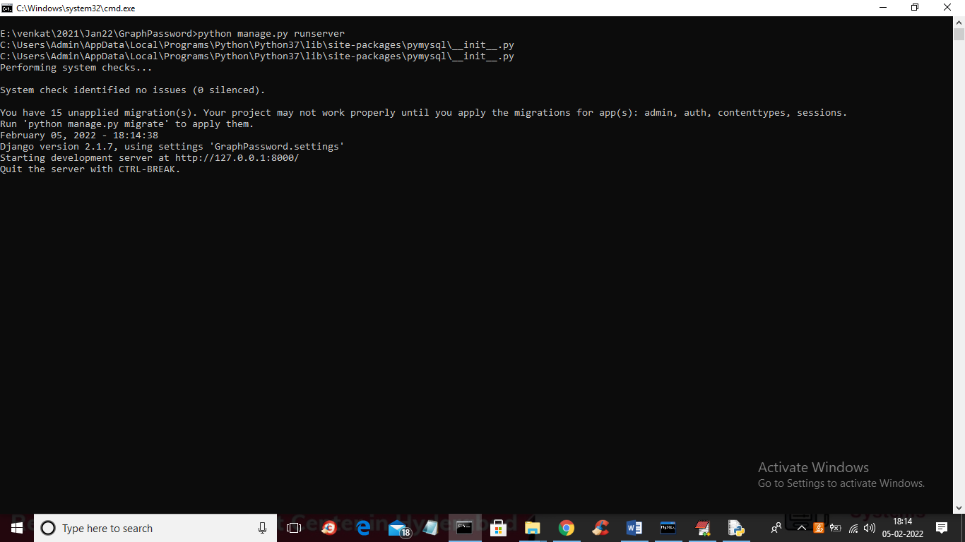

In above screen DJANGO server started and now open browser and enter URL as <http://127.0.0.1:8000/index.html> and press enter key to get below page

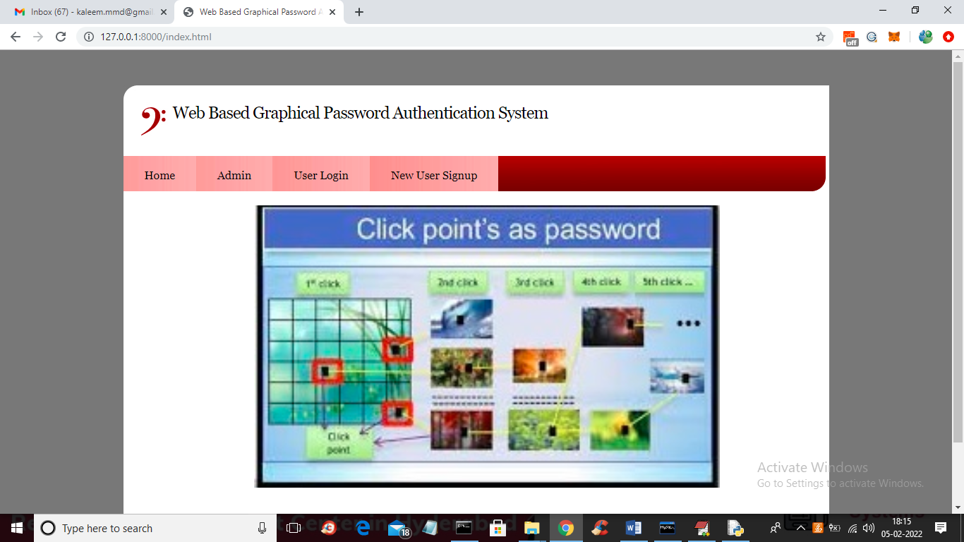

In above screen click on ‘New User Signup’ link to add new user details

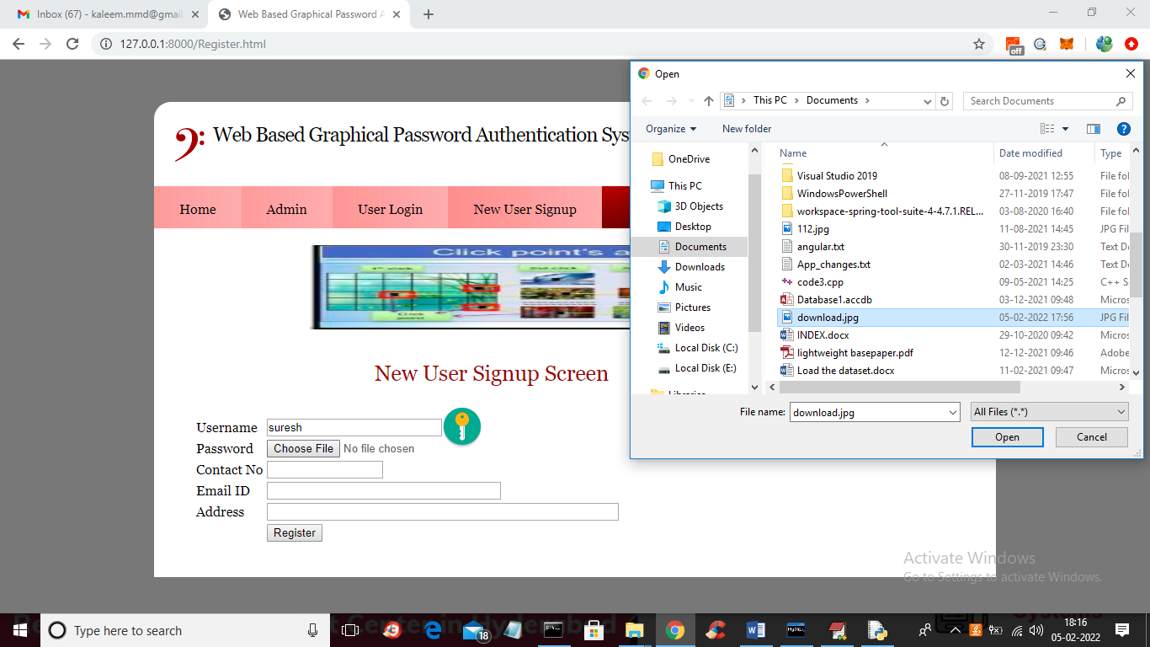

In above screen user is entering signup details and in place of password browsing and uploading image and then enter remaining details

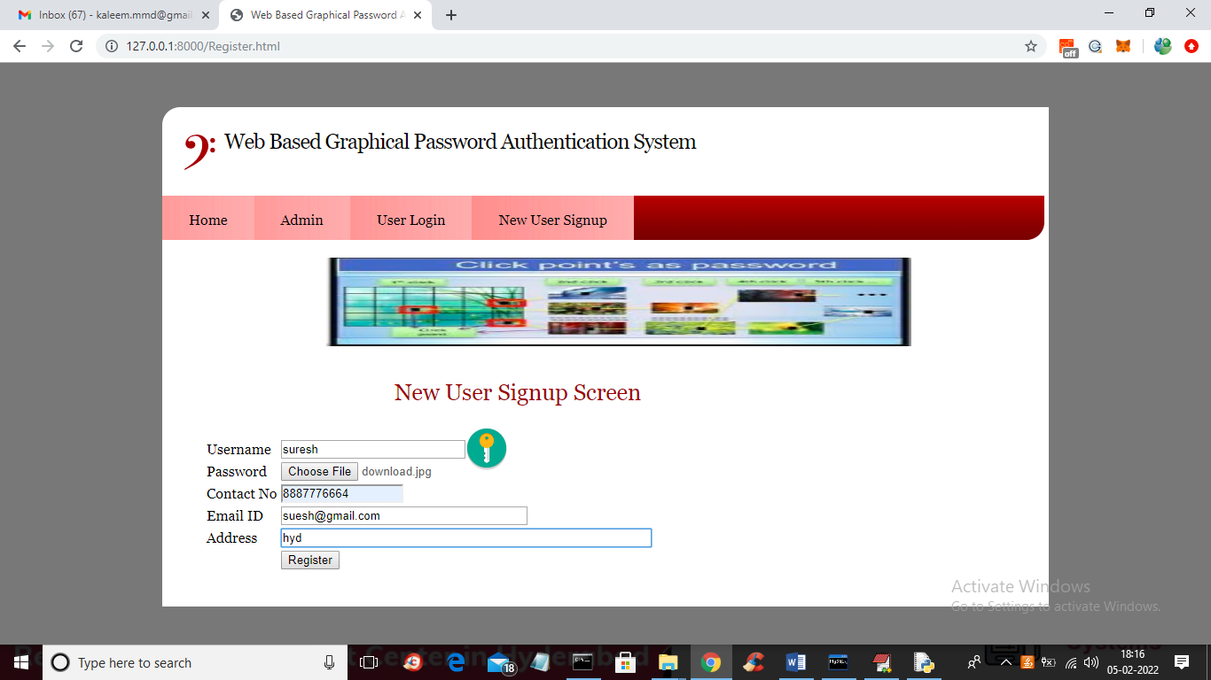

In above screen after entering all details click on ‘Register’ button to get below page with image

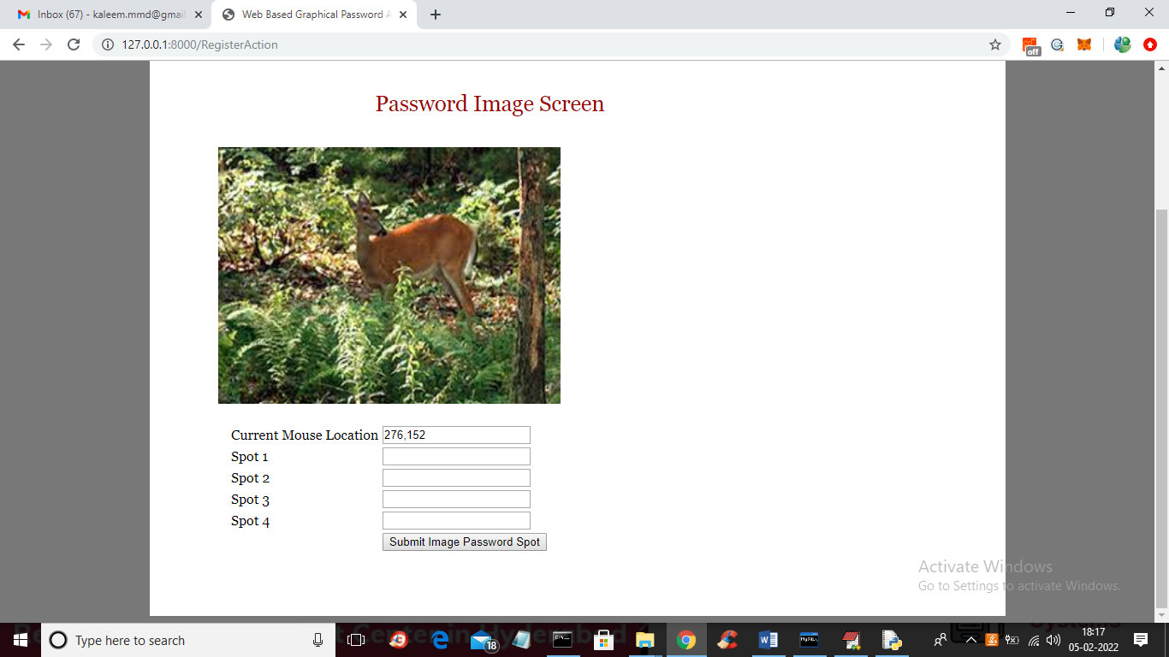

In above image user has to click on any part of the region then location will be added to text fields and first field will display the current location of mouse so you will know which point your mouse is at and u need to select 4 spot and then will get below screen

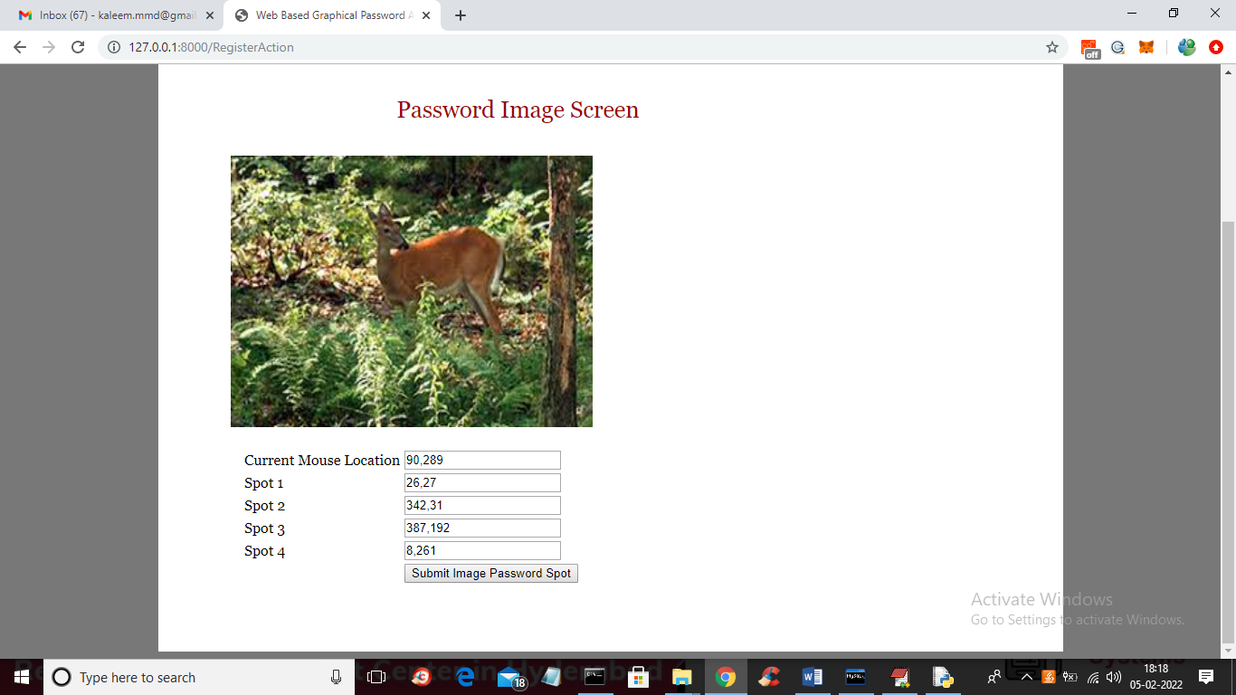

In above screen I selected 4 spots and all those X and Y selected values are filled in the text fields and then press button to get below page

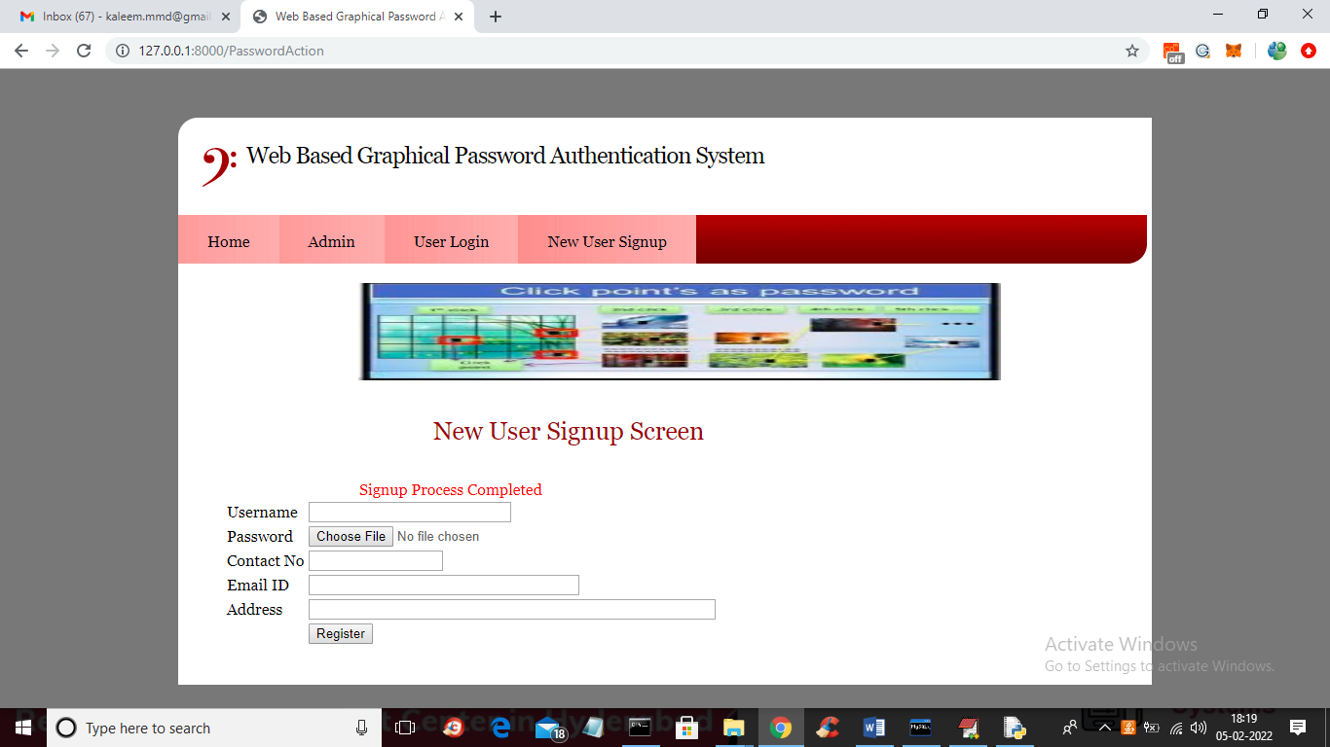

In above screen we got message as ‘signup process completed’ and now click on ‘Admin’ link to login as admin and view all user details

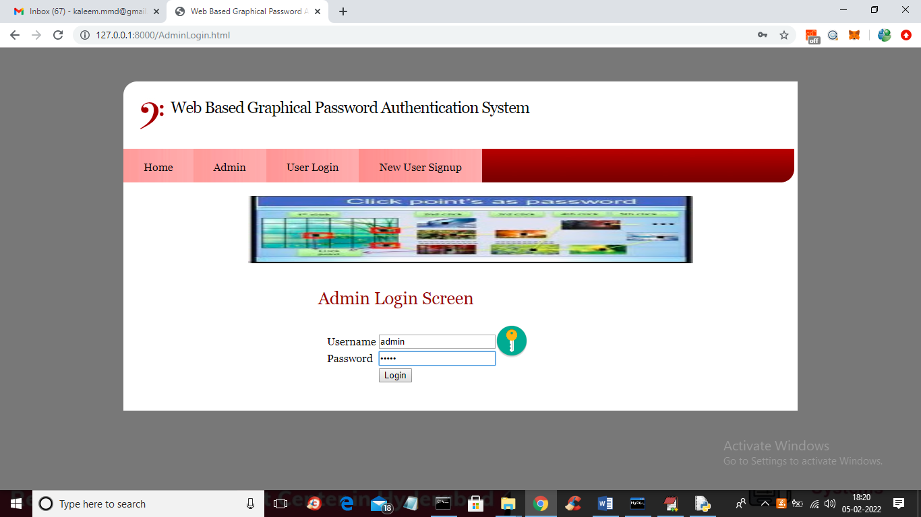

In above screen admin is login and after login will get below page

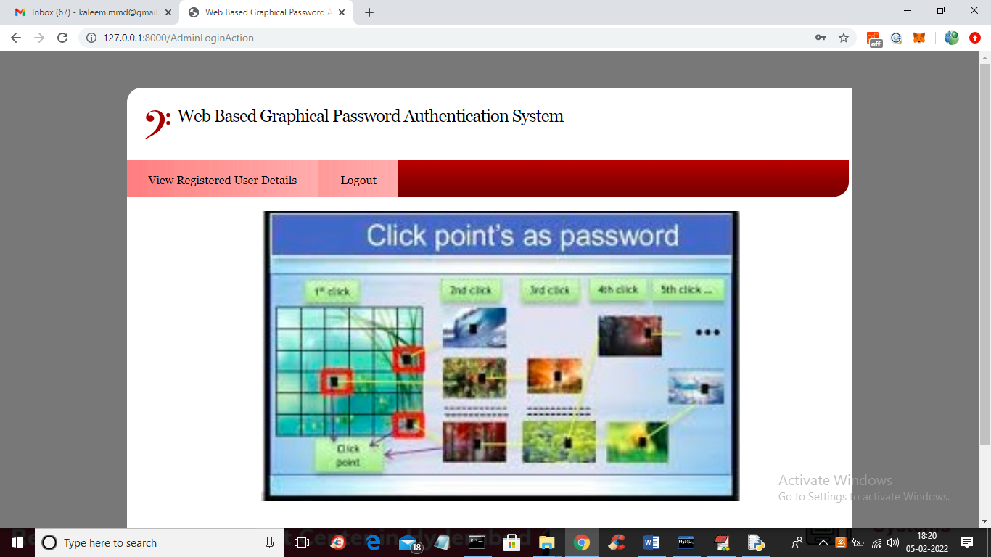

In above screen admin can click on ‘View Registered User Details’ link to get below page

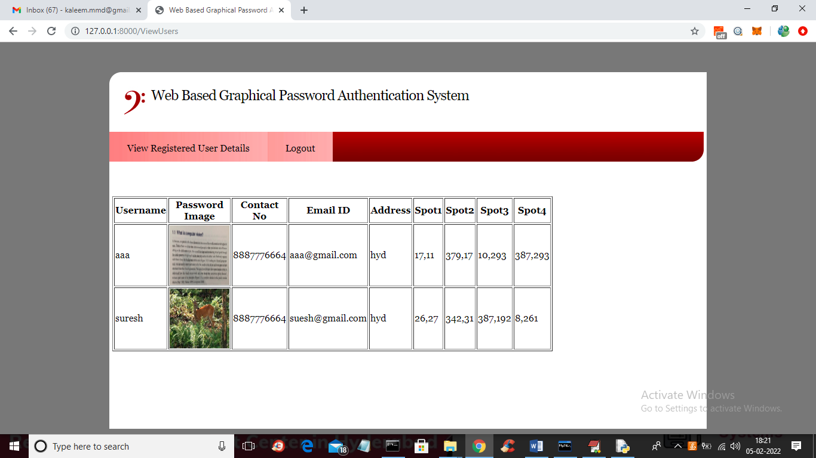

In above screen admin can see all users details such as username and password as image and selected 4 spots and now logout and login as user suresh

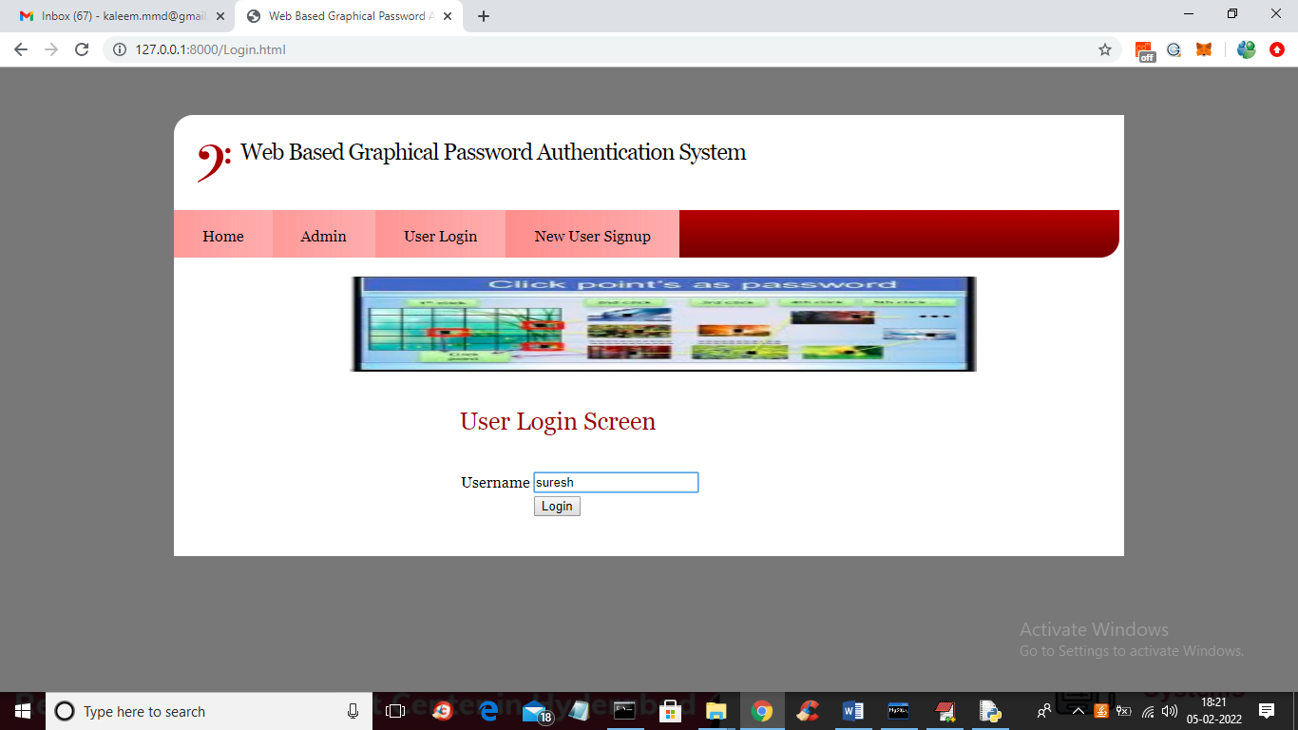

In above screen user is login by entering username and then press button to get image and to select spots like below screen

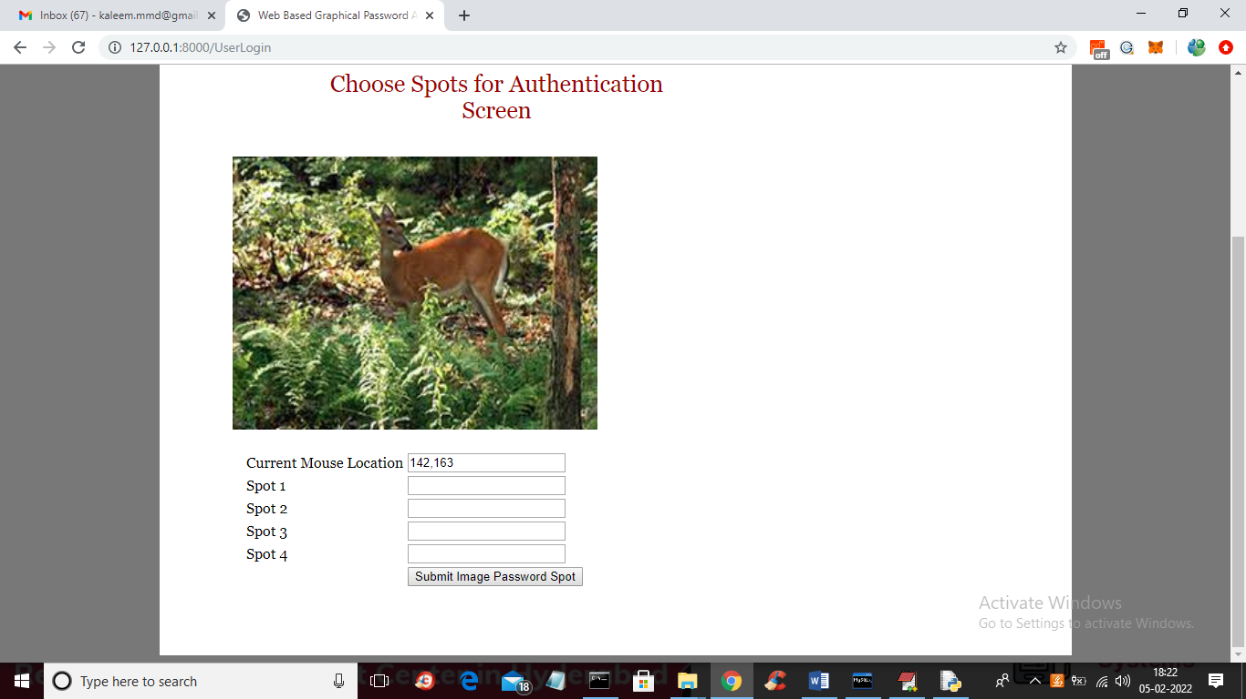

In above screen for login also user has to select 4 spots and then press button to authenticate

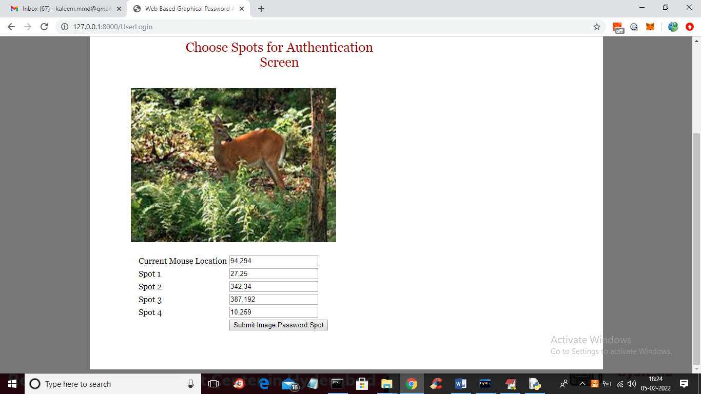

In above screen I selected values in range and then press button to get below screen and if given spots falls between correct password spots in database then user will get authenticated and get below screen

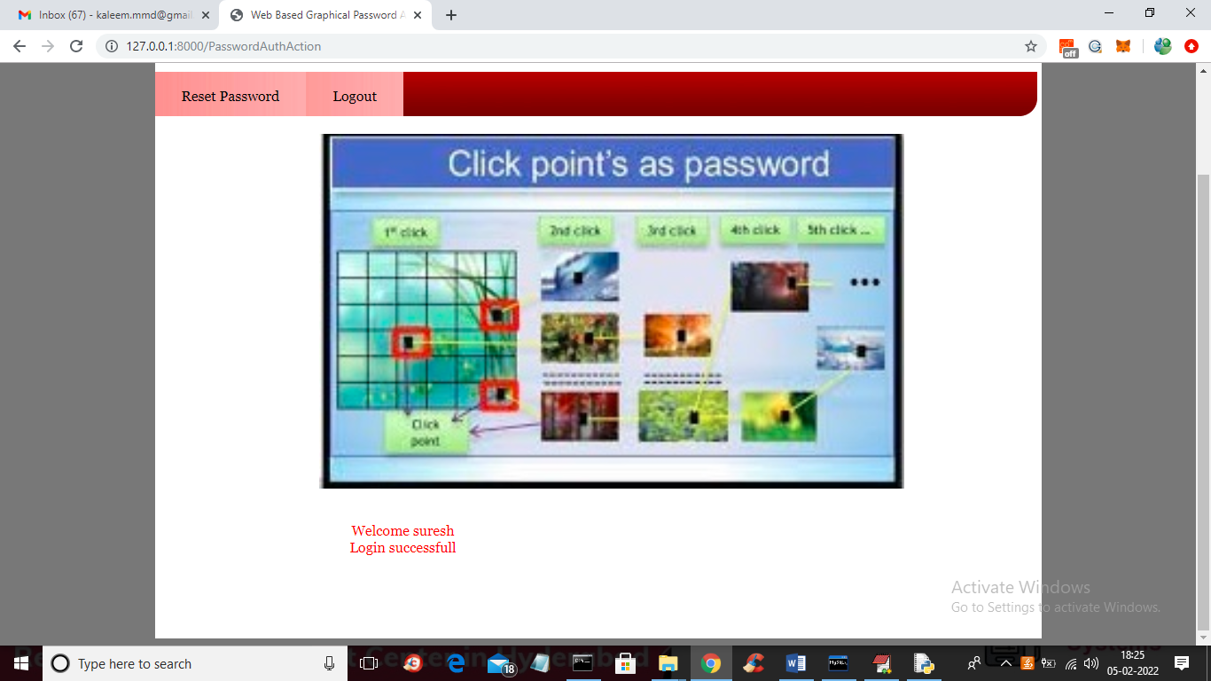

In above screen in red colour text we can see login is successful and if u give wrong details then authentication will get failed and if you want to reset password with new image and spots selection then click on ‘Rest Password’ link and repeat same steps.

NOTE: in any field if values are available then just delete those values from the field so new selected spot values can be appear